**SPRING BATCH ARCHITECTURE**

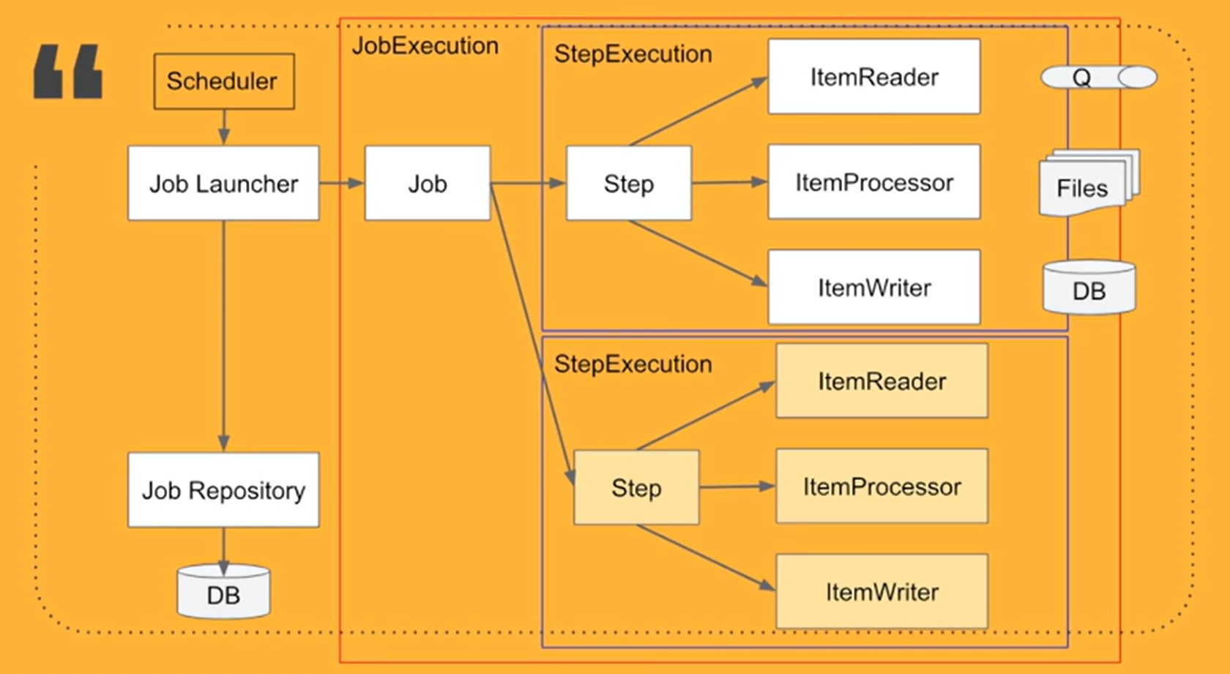

**SRC**: <https://youtu.be/16bq_N55f_s>

**Example**

**SRC**: <https://youtu.be/1XEX-u12i0A>

**Description:**

* Spring batch will run job in some specific timestamp or scheduled time.
* Spring batch consist of three main steps
  + Creation of Job
  + Creation of Job launcher
  + Saving Job details in DB via Job Repository
* All the execution of Job will store in Batch(s) table in DB.

1. **Creation of JOB** - Job consist of step. A Job can have single of multiple steps.
   1. Step is divided into three parts
      1. ItemReader – This is a interface, that act as source of data. In the given example, source is CSV file, from which we are reading data. Source can be anything which contains data like database, Cloud file system etc.
      2. ItemProcessor – This is a interface that act as intermediate processor, conversion of data into some other form. For example, data read from csv file is converted into specific POJO. That pojo is than used for further processing.
      3. ItemWriter – This interface act as final step for job, save the data to the target system. For example, saving the POJO to data base.
2. **Creation of Job Launcher** – Once the job is created, it’s the responsibility of Job Launcher to handle the job and its scheduling. We can schedule the job on the basis of some cron Job scheduler. It will initiate the Job on given time.
3. **Saving Job details in DB via Job Repository** – Spring boot provide set of tables for auditing in Spring batch framework. All this table can be used as reference for scheduled jobs to be status and task performance auditing.

**Implementation of Job using Tasklets and Chunks**

Spring provides batch implementation in two ways –

1. Tasklets – In a scenario, when we want to perform batch operation one at a time on whole data, then we can follow Tasklets approach.
2. Chunks – When there is a huge data, and we want chunks of data to pe processed and to save or manage memory of system, then we can follow Chunk approach.

SRC: https://github.com/eugenp/tutorials/tree/master/spring-batch